

*shell programming*

aSsignment -7

**SUBMITTED BY: SUBMITTED TO:**

**AYUSH KUMAR JHA Dr. Dhiviya Rose**

**SAP ID - 500086400**

**Enrollment no - R200220083**

**B.C.A -I.O.T.**

bg – to send a process in background



fg – to run a stopped process in foreground



top – details on all active processes

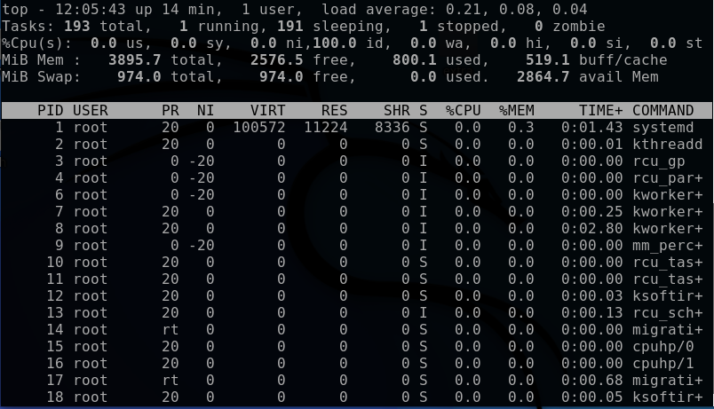



ps- give the status of processes running for a user

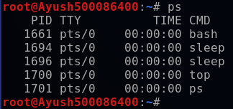

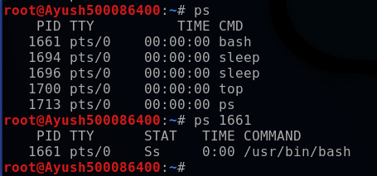

kill - kills the process

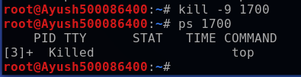

nice-starts a process with given priority

